**CSE103L Circuits & Systems-I Lab**

**Circuits And System 1**

**LAB REPORT # 6**

2020

**Submitted to:**

**Engr. Faiz Ullah**

**Submitted by:**

**TAYYABA**

**Registration No:**

**19PWCSE1854**

**Semester: 2nd**

**Class Section: C**

“On my honour, as student of University of Engineering and Technology, I have neither given nor received unauthorized assistance on this academic work.”

Student Signature: ______________

Thursday, March 12, 2020

**Department of Computer Systems Engineering**

**University of Engineering and Technology, Peshawar**

**ASSESSMENT RUBRICS LAB # 6**

**Verification of KCL using PSPICE**

|  |  |  |  |  |
| --- | --- | --- | --- | --- |
| **LAB REPORT ASSESSMENT** | | | | |
| **Criteria** | **Excellent** | **Average** | **Nill** | **Marks Obtained** |
| 1. **Objectives of Lab** | All objectives of lab are properly covered  [Marks 0.5] | Objectives of lab are partially covered  [Marks 0.25] | Objectives of lab are not shown  [Marks 0] |  |
| 1. **Kirchhoff’s Current Law**   **(Statement, Mathematical Expression, Circuit Diagram)** | Correct KCL statement and mathematical expression is written. Circuit diagram shown is correct and properly labeled  [Marks 1] | KCL statement or mathematical expression or circuit diagram is missing or circuit diagram is not properly labeled  [Marks 0.5] | |  |
| 1. **PSPICE**   **Simulator** | Brief introduction of PSPICE simulator  [Marks 1] | Brief introduction of PSPICE simulator  Is not shown  [Marks 0] | |  |
| 1. **Procedure** | All experimental steps are shown in detail  [Marks 1.5] | Some of the experimental steps are missing [Marks 1] | Experimental steps are missing  [Marks 0] |  |
| 1. **Observations & Calculations** | All experimental results are completely shown in form of table for both cases of using same resistors and for different resistors with varying applied source voltage  [Marks 4] | Experimental results are partially shown and some of the observations are missing  [Marks 2] | No experimental results are shown  [Marks 0] |  |
| 1. **Analysis** | Analysis and discussion about all experimental results are shown  [Marks 2] | Analysis and discussion about experimental results are partially shown  [Marks 1] | Analysis is not shown  [Marks 0] |  |
| Total Marks Obtained:__________  Instructor Signature: ______________________ | | | | |

**Verification of Kirchhoff Current Law (KCL) using PSPICE**

Objectives:-

1. To learn about Kirchhoff’s Current Law (**KCL**) , its mathematical expression and its circuit diagram..
2. Learn to draw circuit for **KCL** in **PSPICE** software.
3. To verify **KCL** using **PSPICE** software.

Kirchhoff’s Current Law:-

Kirchhoff’s Current Law states that the sum of current into a junction is equal to the sum of current out of junction. The junction is a point where two or more then current paths joins together.

**Circuit Diagram:-**

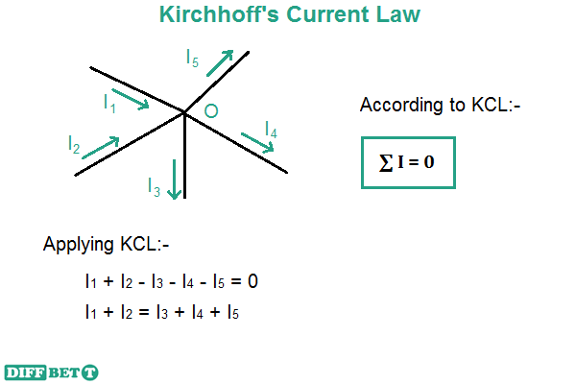

**Mathematical Expression:-**

According to above diagram:

Iin = Iout

I1+I2 = I3+I4+I5

I1+I2 - I3 - I4 - I5 = 0

PSPICE Simulator:-

**PSPICE** is a computer-aided simulation program that enables you to design a circuit and then simulate the design on a computer. As this is one of its main purposes, it is used extensively by electronic design engineers for building a circuit and then testing out how that circuit will simulate. There are a lot of things we can do with **PSPICE**, but the most important things for you to learn are

1. Design and draw circuits.
2. Simulate circuits.
3. Analyze simulation results.

Procedure:-

1. Run the **PSPICE** software. A blank window will be opened.
2. Click on “**Get New Part**” from toolbar.

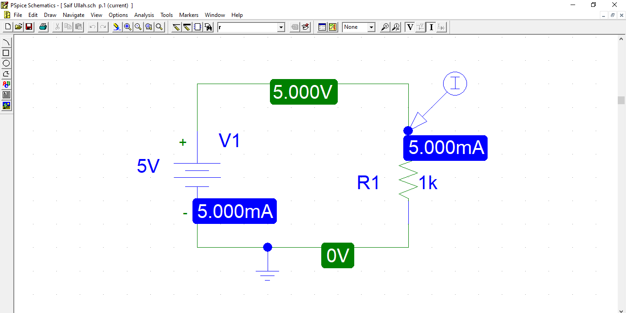

**GET NEW PART**

1. Type on **part name** and name part we want. Suppose we want **DC Voltage** so we will type **VDC**

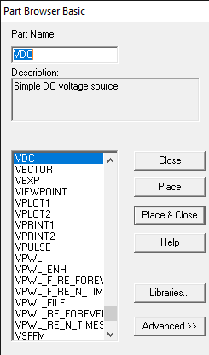

1. Place it and assign its name and set the voltage.

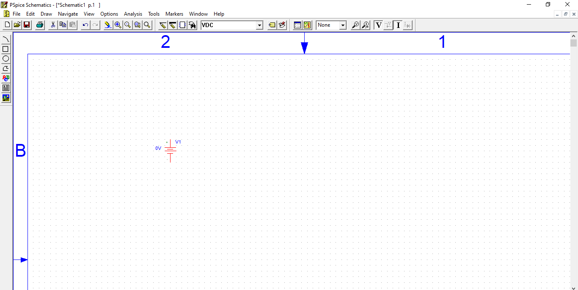

1. Now again click on “**Get New Part**” and type **r**. place one such that the resistor is connected in **series** and place two resistor such that they are connected in **parallel**. Assign the resistance to each resistors.

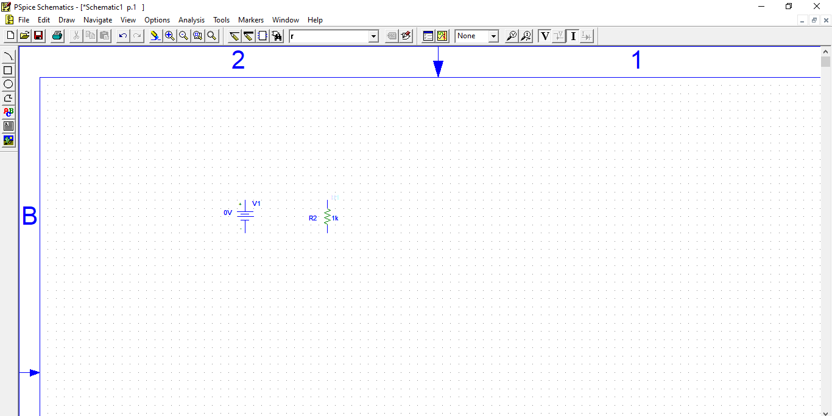

1. 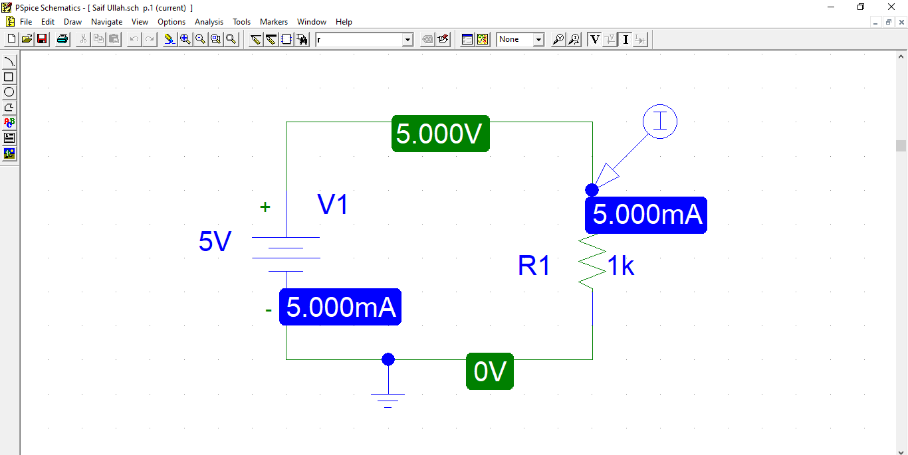Connect the whole circuit using “**Draw wire**” from toolbar.

**Draw Wire**

1. Then again click on “**Get New Part**” and type **GND** and place ground at the end of circuit.
2. Arrange the component according to this diagram:

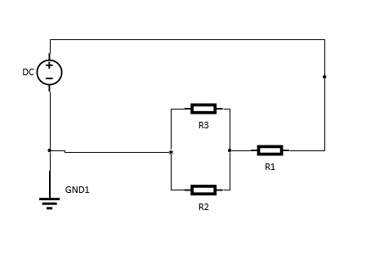

1. Now click on “Simulate”.

**Simulate**

Observation & Calculation:-

**Case 1 (Same Resistors):-**

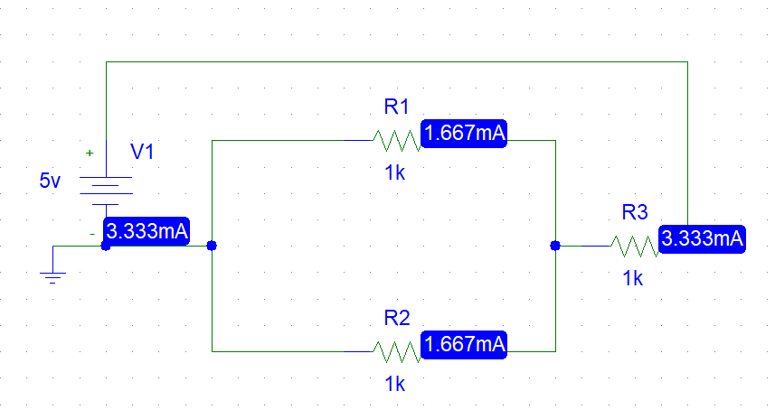

**Table(Case 1):-**

|  |  |  |
| --- | --- | --- |
| **Sr. No.** | **Resistance** | **Current** |
| 1 | 1k Ω | 166.67 uA |
| 2 | 1k Ω | 166.67 uA |
| 3 | 1k Ω | 3.333 uA |

Analysis:-

As from experimental data we can easily observe that the current going inside the circuit is equal to current going outside the circuit. As in above diagram, the flowed to **R3** and **R1** and **R2** . Their sum is equal to total current supplied to that point.

**I3 = I1 + I2**

3.333 uA = 166.67 uA + 166.67 uA

**Case 2 (Different Resistors):-**

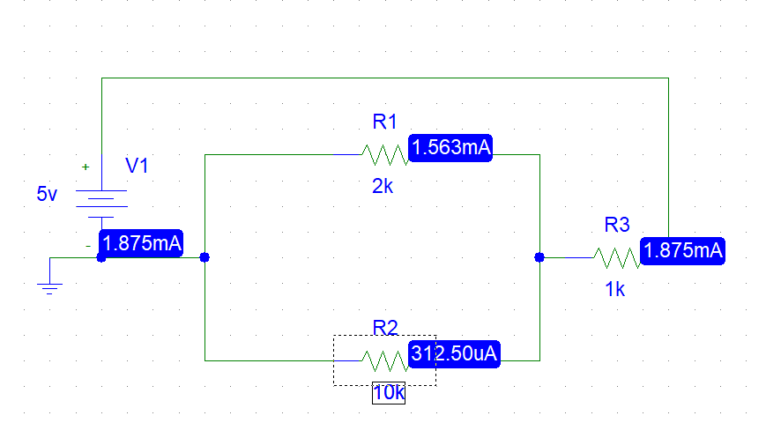

**Table (Case 2):-**

|  |  |  |
| --- | --- | --- |
| **Sr. No.** | **Resistance** | **Current** |
| 1 | 2k Ω | 1.563 mA |
| 2 | 10k Ω | 312.5 uA |
| 3 | 1k Ω | 1.875 mA |

Analysis:-

As from experimental data we can easily observe that the current going inside the circuit is equal to current going outside the circuit. As in above diagram,current flowes from **R3** to **R1** and **R2** . Their sum is equal to total current supplied to that point.

**I3 = I1 + I2**

**1.875mA = 312.50uA + 1.563mA**

**1.875mA = 1.875mA**